**Kim HUYNH**

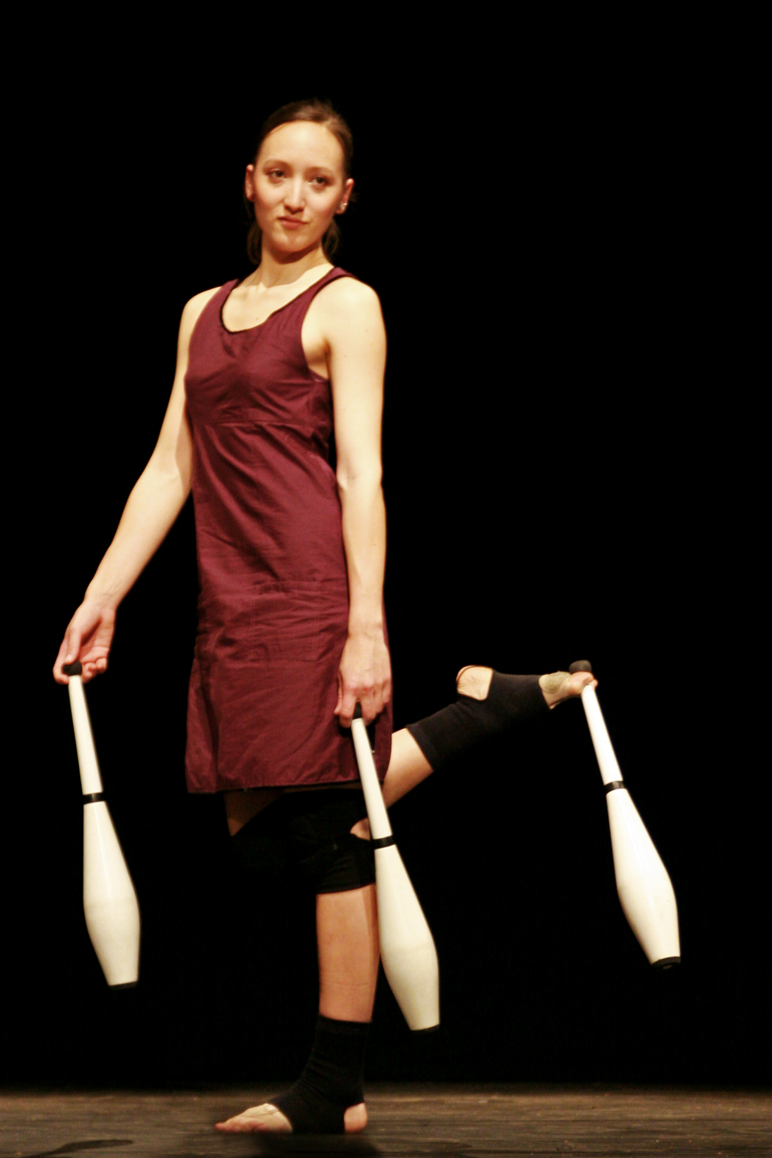

58 rue des Noyers

93170 Bagnolet

Tel.: 0663072805

E-mail : kruemelkim@yahoo.fr

Birth date :27 mars 1980

Nationality : francaise

Having started to dance ballet at the age of 4, I complete my formation as a dancer in 2003 with a certificate of “**choreographical studies**”, delivered by the dance school (conservatoire) of Saint Denis, France.

**From 2000 to 2004**, I continue taking contemporary dance lessons and perfect my juggling skills in participating in juggling events and workshops.

**In March 2004**, I start working on a research project with Jérome Thomas that aims inventing a corporal language in order to create the first juggling ballet.

**In March 2005**,I join the **Company Jérome Thomas** for the creation of ***Rain/ Bow*** that has been performed more than 100 times between 2006 and 2008 in France and abroad.

**In 2007** I create **« Windy »**, a solo juggling act mixing club juggling and dance.

**In 2008**, I participate in the creation of the show « **Libellule et papillon** » de Jérome Thomas, a show on roller skates.

At the same time I’m part of the **collective “Bicubic”**, that mixes juggling, object manipulation and numeric arts. The resulting show, also called Bicubic, is performed at the festival Jonglissimo in Reims in 2008.

**Since 2009** I regularily work with **« Gandini juggling »**, a company based in London. Recent creations : **“Smashed”,** a juggling show in honor of the choreographer Pina Bausch. **“Quartet”**, a show combining juggling and classical live music, played by the regional orchestra of the Normandy.

**« Blotched »,** a juggling show inspired by the painter Jackson Pollock.

**In 2009** I create the company **Cie *Sens Dessus Dessous*** with Jive Faury and since work with him on choreographical juggling.

**In 2010** we create **“Linéa” (Sens dessus dessous)**, a show that mixes juggling, dance, object manipulation and puppets using only one type of props which is the rope.

**In March 2010** I join the **company 14:20** which initiated the movement of **“magie nouvelle”**. I took over the **solo “étoiles”** with glowballs, am actually performing in **“Notte”**, and have a substitute role in **“Vibrations”**.